Coming soon: Ubiquitous Computing
A Revolution in IT or Just Annother Hype?
Bernd Lutterbeck
Berlin University of Technology

Entrepreneurs’ High Level Forum
Dalian (PRC), June 22th, 2005
Abstract
Recently, modern societies have learned to handle a structure which they named «information societies.
Today a new type of IT-technologies is «knocking on our doors»: Persasive or Ubiquitous Computing. A new name for this structure is still missing, allthough experts are confessed: We witness a new era of computing, which will challenge our ability to govern the new structure of decision making in ous societies. In this paper (together with an presentation) I argue that understanding the ongoing trends of decentralization and cooperation within our firms and other institutions will lead to both political and economic answers.

Content
The Portfolio: Tales from the Past 1
Three Megatrends: Pervasive Computing, Decentralization and Cooperation 1
Pervasive Computing 1
Conclusion 1
Bibliography 2

The Portfolio: Tales from the Past
In 1993, only but 10 years ago, the European Union looked for a name or a term to describe what is happening in the field of Information Technology. The politicians of this era knew that the portfolio of the various technologies represents an economoic sector which is crucial for prosperity and quality of life in the Union with its 360 Billion inhabitants.
They decided to build a new sector of political activities and named it «Information Society», using a neologism which was popular mostly among American academics. Since than Europe has its own Commissionar or Minister for the information society, together with responsibilies for the media since some years:
«This portfolio stretches from the underlying communications infrastructures to the content and services they deliver. It encompasses telecommunication networks, broadband internet access and satellite communications, new communications technologies such as ‘3G’ mobile communications and Internet telephony, and digital material as diverse as cinema releases and advanced eHealth services.»
Thus, the information society with its necessary political and economic activities is well established in Europe. Some countries like Finland are leading the competition among the prominent IT-- contries in some sectors.
But, according to my heading these are success stories of the past. Not litterally: ‘3G’ communications for example are not yet in practise, at least in most European countries and I wonder wether there is a mass market for Billions of new users in the near future. What makes these strories tales of the past is a fact which is not yet in the minds of the public and, in the minds of our politicians. It is an ongoing revolution in the field of network technologies, specially sensor networks.
Some academics argue «Don’t worry, it is just annother hype!» Granted, some of their arguments are confessing. You cannot really predict the future and one should be very cautious to name something as revolution. Sociologists argue that you could be sure not until hundreds of years. On the other hand, all of us who live today and have to decide right now should be aware of the consequeces of these new technologies – today and not in a dusty future. Weighing all arguments against each other I plea for the latter. My thesis is as follows:
Pervasive Copmputing will change our societies, dramaticly.
It is an chicken and egg-problem what comes first: the society or technology. At any rate: We have to learn communicating in a different way from what we have done in the past.
We have to shape the furture with new forms of cooperation.
Cooperation is our next lesson. E-Learning is too simply an answer: obvious, but false.
Three Megatrends: Pervasive Computing, Decentralization and Cooperation
Once humans act they build an order of behavior: That’s what we mean if we use the term society. Humans need this order, to build trust to each other. Without trust no society can exist – neither an European society nor a Chinese one. In times like ours rapid changes of human’s behavior could destroy this order of trust. For better or for worse we should identify this new order. Otherwise acting upon may be too costly for all.
Their is a broad consensus at least among academics that three megatrends will determine the next future of 10 to 20 years:
- Technological Trend: Pervasive Computing
- Societal Trend: Decentralization of decision making
- Economic Trend: Cooperation pays
This mixture out of technical, economic and social circumstances will determine the very conditons for political decision making. If we read these trends wrong our IT-strategies might be wrong, too. In most times we have to pay for our incompetence in terms of loss of competition.
In the remainder of my talk I shall concentrate on technology. I deliver just some remarks about decentralization und cooperation
Since hundreds of years economists dispute what the very incentives for humans are to act or to omit actions. What is the very nature of economic incentives or preferences? Generations of students all over the world learned as axiomatic truth:
«People’s preferences are ‘self-regarding’ and ‘outcome orietiented. In other worlds, people want stuff for themselves, and care only about their personal cost in getting what they want. There is much evidence, both from within economics, and from other disciplines, that this view of human nature misses a lot. people care both about other people, and about how social, transactions occur – not just the outcomes.» (Henrich ea 2004, p1)
To sum up in a nutshell: People are altruistic by nature rather than selfish - given certain kinds of reprocity! If this was true we have strong evidence for a rather new phänomenon in the IT-sector: the success of open source software.
The second trend of decentralization will certainly contribute more to the agenda of our ongoing conference. The findings are extremely important for the management of firms and even institutions of the states. Thomas Malone from MIT Sloan Management School has the facts integrated to a figure he named as «Decentralization continuum».

We see a process, starting from the the bands of ancient times up to Internet communities in our times. We can see that centralization is a modern phänomenon due to the nessessities of life in these eras.

The institutional patterns of our time are simular more networks than the classical type of hierarchical organization.To quote Malone: The pattern are rather simple and forshadow how business might be done today or tomorrow:
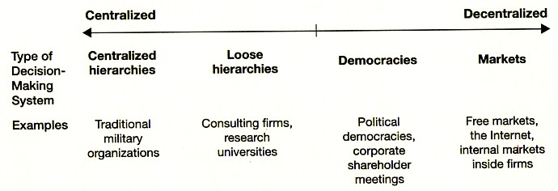
«The mayor changes in how businesses were organized echo the changes in how societies were organized.»
In a shortcut: It is efficient, in a strong economic sense, to structure given organizations by decentralized decision making – at least in some cases if not the most.
The next figure shows the structure of one of the leading consultant firms of America.
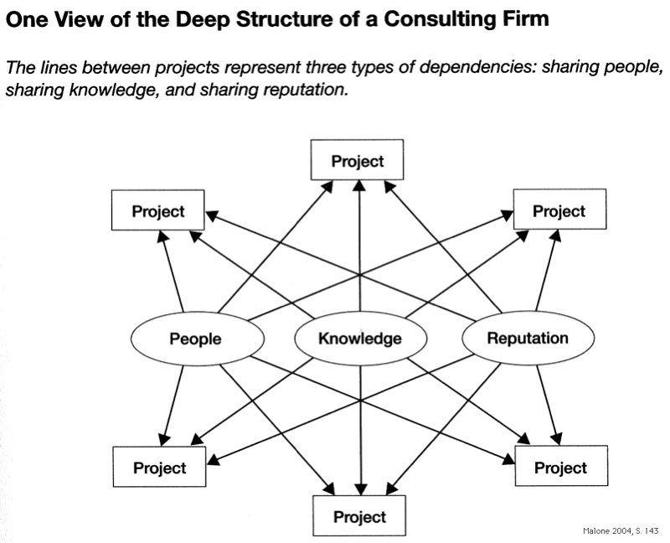

The capital of this firm is summarized Malone: «Sharing people, sharing knowledge, sharing reputation.» An obvious result of this change to decentralized decision making is the fact that todays innovations often are driven by users and not manufacturers. This remark might sound strange for Chinese ears, but American estimations range up to 20% of all economic activities which might be user driven in the near future. The following table delivers evidence for this type of user driven innovation: (Malone 2005, p 20)

Without any dought one can assume that the decreased communications costs made this forms of cooperation and decentralized decision makong possible. The transaction costs are nearly zero:
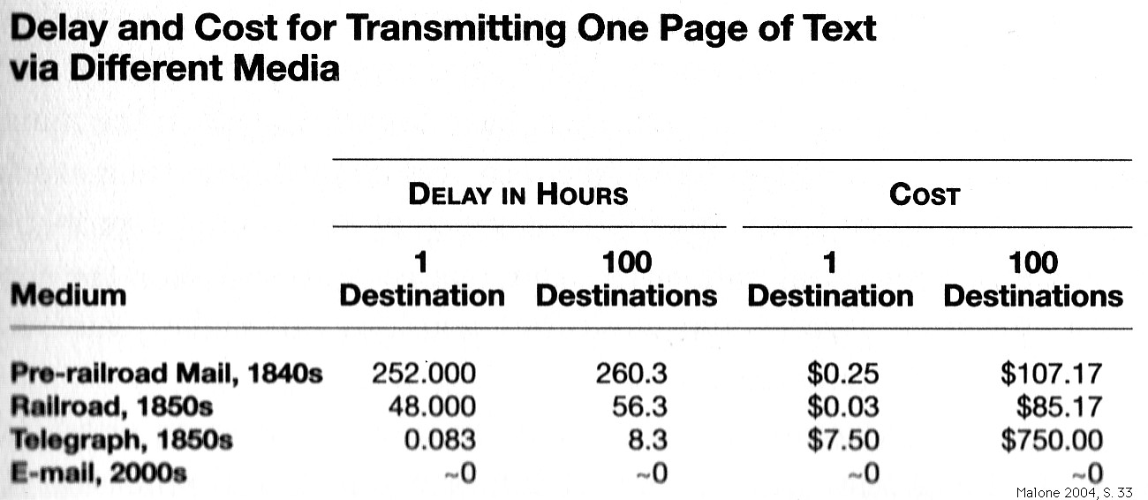
That brings me to the main point of my contribution: The trend of technolgy towards «ubiquitous» or how it is also called «pervasive computing».
Pervasive Computing
"Ubiquitous computing names the third wave in computing, just now beginning. First were mainframes, each shared by lots of people. Now we are in the personal computing era, person and machine staring uneasily at each other across the desktop. Next comes ubiquitous computing, or the age of calm technology, when technology recedes into the background of our lives."
These are the worlds of Marc Weiser, who developed this vision for Xerox Parc aroumd 1990. (next two figures taken from a presentation of (Mattern 2003)
And in annother article he wrote:
«The most profound technologies are those that disappear. They weave themselves into the fabric of everyday life until they are indistinguishable from it.»
What was 1988 merely a vision of an unknown Californian Engineer becomes now reality in our daily lifes. I will give you empirical evidence in two examples: one from agriculture, one from selling and perchasing goods. I will start with some exemplanations about the technology itself
Friedemann Mattern, Swiss computer scientist and one of the world’s leading experts summarizes the various trends in techology:
«All trends together will lead to a new era»

The trends emcompass
- progress in sensor technologies
- miniaturization of storage technologies
- new networks, specially wireles networks
and
- various technologies at the backend
Not to forget the Internet as basic infrastructure for communication.

I would like to illustrate with two cases, which seem to lie apart from each other. They may give an impression of the silhouette of the new era.
My first example is vineyard computing. (Burell ea 2004; www.lofar.org)

This vineyard is situated in Bristish Columbia (Canada) with special weather conditions and rather raph a climate. A wireles sensor network will support farmers in descision making: Giving them data «about temperature, lighting levels. humidity, the movement and presence of people, and many other aspects of the environment». Researchers from Intel Corporation came in 2004 to the conclusion that vineyard computing 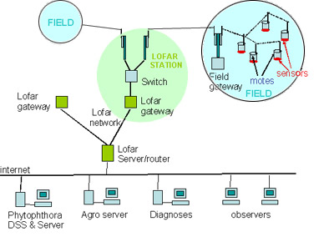was not just an application of fairly new technologies but the creation of a completely new environment. And the researchers had to confess that they did not understand the structure of this new «calm» environment. Not pervasive computer technologies but unsolved problems of the application space provided the then unsolved challenges.

My next example is withdrawn from the world of merchants, sellers and purchasers of goods: The Prada stores in New York and Tokyo.
Kang and Cuff decsribe the Prada store New York as follows
«The full-block store is organized as an interior street, called theWave by the architect (see above image), with a set of metal boxes floating above for the few products displayed in this new form of nomadic shop window. The vast space is open for walking, watching, and less apparently, buying. Instead, Prada uses architecture in conjunction with digital technology, to create urban identity and branding. The store has become a public event, aided by in-store technology. This includes glass dressing rooms that phase-change from transparent to opaque, large video screens that replace store mirrors to show your back and side views live, data banks like ATM machines that check inventory, and a series of embedded sensors that track what you take into the dressing rooms. Within the dressing rooms are smart closets that read a garment’s RFID tag to display additional details, possible accessories, similar items with the same look, and how it looks modeled on the runway. Prada is considering additional technologies, including scanners that charge the customer automatically when a customer carries a product out the door.»
(Kang/Cuff 2005, p 26)
Kang and Kuff are architects and lawyers and plea for common projects of computer scientists, lawyers and architects. to understand the new urban environment. They drew an analogy to the shopping malls of America like the one in Bloomington They suppose:
«After all, in many urban environments, malls are arguably what our public spaces have become. The accessible, open space of the street has been ingested by shopping malls, which in turn have invaded most urban spaces, from airports to museums.
(Kang and Cuff 2005, p. 25)
Conclusion
Pervasive Computing is not yet a new hype. A fufuture with Pervasive Copmputing is unescapable:
«In sum, decentralized economic, social, and cultural forces will lead to the widespread and significantly unavoidable adoption of PerC in the next two decades. We have less time than that to plan.»
(Kang and Cuff 2005, p 8)

Pervasive Computing is an extremly powerful device for creating various new environments. The power of these networks will result in a different behavior of people and thus a new structure of society.
Therefore our societies probably had to redefine and reengineer public space.
Our societies will pass these challenges if they understand the central lesson of today: There is no efficient alternative to decentralized decision making. Pervasive Computing may help to take the next step forward.
Bibliography

Yochai Benkler (2004): Sharing nicely: On Shareable Goods and the Emergence of Sharing as a Modality of Economic Production. Yale Law Review Vol. 114, pp 273- 358, download http://benkler.org/SharingNicely.pdf.
Jenna, Burell ea (2004): Vineyard Computing: Sensor Networks in Agricultural Production. Pervasive Cumputing January-March 2004, pp 38-45.
Joseph Henrich ea (ed) (2004): Foundations of Human Sociality. Economic Experiments and Ethnographic Evidence from Fifteen Small-Scale Countries. Oxford University Press: Oxford, New York.
Eric von Hippel (2005): Democratizing Innovation. The MIT Press: Cambridge and London. [download http://web.mit.edu/evhippel/www/books.htm].
Jerry Kang; Dana, Cuff (2005): Pervasive Computing. Embedding the Public Sphere. Social, Science Research Network Paper Collection, http://ssrn.com/abstract=626961.
Bernd Lutterbeck, Robert A. Gehring, Matthias Bärwolff (ed) (2005): Open Source Jahrbuch 2005 [Open Source Yearbook]. Lehmanns Media: Berlin [download of the German version, www.opensourcejahrbuch.de].
Thomas W. Malone (2004): The Future of Work. How the New Order of Business Will Shape Your Organization, Your Management Style, and Your Life. Harvard Business School Press.: Boston.
Friedemann Mattern (2003): Pervasive Computing: Wonderful Future or Fabolous Illusion? Engelberg Lecture as of October 2003, http://www.vs.inf.ethz.ch/publ/selected_talks.html.
Frank Pallas; Sarah Spiekermann (2005): Technology Paternalism – Wider Implications of Ubiquitous Computing. Poiesis and Praxis Autumn 2005 [forthcoming].

For further examles from the US see (Benkler 2004) with case studies about car pools and distributed computing.

